## Private Cloud Setup with User Storage Management

Introduction

With the rapid growth of the internal volume of enterprise data, it causes many problems in terms of storage, such as the lack of adequate hardware storage devices, high maintenance costs, and incomplete storage environment and so on. Cloud Computing technology can provide customers with the corresponding demand services that can effectively address these issues.

Cloud Computing provides us by which we can access the applications as utilities, over the Internet. It allows us to create, configure, and customize applications online. With Cloud Computing users can access database resources via the internet from anywhere for as long as they need without worrying about any maintenance or management of actual resources.

However there are security and privacy concerns to be addressed before customers readily outsource their sensitive data. To be effective, a cloud storage service should provide, at a minimum, features and security guarantees like confidentiality, integrity, availability, reliability, efficient retrieval and data sharing Most cloud consumers want their cloud data and its usage to remain private, so along with encryption of their data objects, they also want their access patterns to be oblivious to the cloud provider.

Purpose

We will design and configure an algorithm to cloud user storage management on HADOOP (VMWARE) at operating system of Linux. Manage user directory by using HDFS (Hadoop Distributed File System) as well create remote user interface. User also managed or checked its storage capacity either available or used.

In this Report we also highlight the feature (Scalability, storage management, Network management, user I.D, multiple node,) of different platform like (Amazon, Google, iCloud, Apache Hadoop)

Survey Report

Cloud Storage and Adoption Trends report, 87 percent of organizations surveyed said they were using the cloud to store some data. However, most of that cloud storage isn't in enterprise-focused cloud storage services. The most popular way to store data in the cloud is in a file sync and share service like Dropbox or Box, and the second most popular is within software as a service (SaaS) applications. Only about one in five (21 percent) use enterprise cloud storage services for their primary data storage

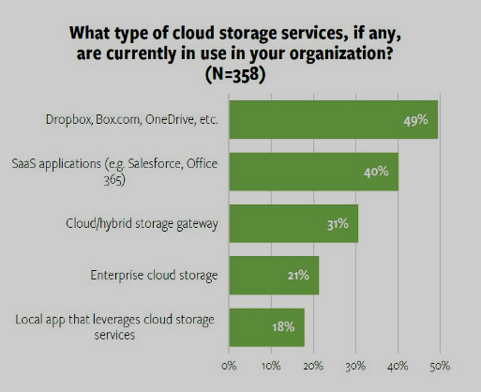

  Cloud Storage and Adoption Trends

But while enterprises aren't using the cloud for their primary storage today, analysts believe that is likely to change in the near future. According to IDC, adoption by large enterprises is a major driver of infrastructure as a service (IaaS) cloud growth, and the market is likely to see increases greater than 20 percent per year through 2020, when IaaS will account for more than a third of enterprise storage spending.

That's a sizable percentage, but it means that the majority of enterprise data will remain in on-premises storage which adds to storage management complexity.

Cloud Storage Features

* **Scalability :** When they store data on-premises, organizations have to forecast their needs far into the future and purchase excess capacity in order to have enough space as their data continues to grow. But with cloud storage, more resources are automatically available as the organization needs them, with no need for over provisioning.
* **Security and File Encryption :** Security is a top concern when you take your business to the cloud. Your company's private data [could be compromised](https://www.businessnewsdaily.com/5215-dangers-cloud-computing.html) if the service you use lacks the right features. Make sure your service encrypts your data at least once before it ever leaves your servers. The best services also allow you to pick your own encryption key so that not even that company's employees can view your files. You should also have the ability to protect your files with a password, particularly when accessing them from a mobile device, as well as the capability to set different levels of access for different employees. Top-notch security features will let you relax when sending private information about your clients to the cloud.
* **Cloud Storage Management Complexity :**

The idea behind cloud storage management complexity is to use computer data storage software for policy-based provisioning and management of data storage independent of the underlying hardware.

Traditional data storage cannot overcome today’s challenges of scale, integration, and flexibility. If your solution for managing data growth is simply to buy more storage capacity, sooner or later you’ll be facing dramatically increased costs for both storage and management. Manually managing across heterogeneous storage systems, silos and clouds is not only error-prone but also leads to administrative overhead.

Software-defined storage addresses these challenges by separating the software that provides the intelligence for storage from the traditional hardware platform. The results include easier storage management, lower storage costs, and anywhere-anytime access to support cloud storage.

Backgroumd

Cloud Storage and Adoption Trends report, 87 percent of organizations surveyed said they were using the cloud to store some data. However, most of that cloud storage isn't in enterprise-focused cloud storage services. The most popular way to store data in the cloud is in a file sync and share service like Dropbox or Box, and the second most popular is within software as a service (SaaS) applications. Only about one in five (21 percent) use enterprise cloud storage services for their primary data storage.

**DESIGN AND IMPLEMENTATION OF PRIVATE CLOUD STORAGE PLATFORM**